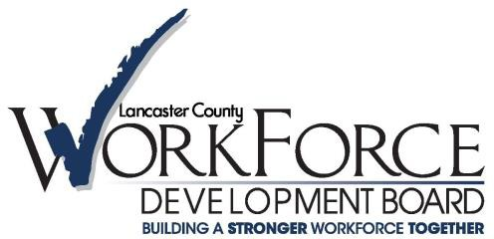

Local Management Committee (LMC)

1046 Manheim Pike, Lancaster PA 17601, 2nd Floor Board Room

Wednesday July 9, 2025 at 9AM

[**Join the meeting now**](https://nam10.safelinks.protection.outlook.com/ap/t-59584e83/?url=https%3A%2F%2Fteams.microsoft.com%2Fl%2Fmeetup-join%2F19%253ameeting_MWY4ZTA5MTktYzkwOS00MTY0LTljZDktNmU5MGY2YTI1OWIx%2540thread.v2%2F0%3Fcontext%3D%257b%2522Tid%2522%253a%25228bb0108f-860e-4670-ac62-00a80fc30e6c%2522%252c%2522Oid%2522%253a%25227a0e5f76-5f83-47ad-a44a-e1ec524fd30c%2522%257d&data=05%7C02%7Ccmccullough%40lancastercountywib.com%7Cfd5e84f2cabd4fa954a808dd147e6dff%7C8bb0108f860e4670ac6200a80fc30e6c%7C0%7C0%7C638689255459248605%7CUnknown%7CTWFpbGZsb3d8eyJFbXB0eU1hcGkiOnRydWUsIlYiOiIwLjAuMDAwMCIsIlAiOiJXaW4zMiIsIkFOIjoiTWFpbCIsIldUIjoyfQ%3D%3D%7C0%7C%7C%7C&sdata=doL2DKkCTCYmoXG%2Fle52KE8kppMuNxMOJ9DGM%2F3F0xU%3D&reserved=0) Meeting ID: 268 036 271 345 Passcode: VH67Lz6L

**Agenda**

1. Welcome, Public Comment
2. Call to Order and Roll Call of Members
3. Consent Agenda
   1. Approval of Minutes from April 9,2025 Meeting
4. Discussion Topic: EDSI and IU13: Career Pathway Guides for EARN Adults.
5. Program Updates-
6. CAO
7. LCWDB
8. PA CareerLink®
9. Around the room
   * Updates of your programs
   * Challenges, resources, and areas of opportunity this partnership could support/help.
10. Adjourn

# Next Meeting- Wednesday October 8th

# Links to check out:

PA CareerLink® Lancaster County: [www.jobs4lancaster.com](http://www.jobs4lancaster.com/)

Lancaster County Workforce Development Board: [www.lancastercountywib.com](http://www.lancastercountywib.com/)

Career Ready Lancaster!: [www.careerreadylancaster.com](http://www.careerreadylancaster.com)

[www.lancastercountywib.com](http://www.lancastercountywib.com/)

1046 Manheim Pike St. |2nd Floor| Lancaster, PA 17601| 717-735-0333

Auxiliary aids and services are available upon request to individuals with disabilities.

Equal Opportunity Employer/Program.