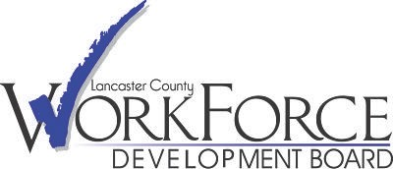

# LCWDB Hybrid Youth Committee Board Meeting Friday, September 8, 2023 at 8:00 a.m.

**Minutes**

|  |  |
| --- | --- |
| Members Present: | In person: Jean Martin, Francis Miliano, John Robbins  Via Teams Video Conference: Michael Berk, Victor DeSantis, Susan Richeson, Joy Tien |
|  |  |
| Staff, Contractors, and Guests: | In person: Mary Byrd, Olivia Monnier-Giansanti  Via Teams Video Conference: Brandy Basile (McCaskey High School), Brianna Dines (TPMA), Ben Hellowski (TPMA), Katie Massell (TPMA), Anna Ramos, Ben Wilson (TPMA) |

# Welcome/Roll Call and Request for Public Comment

At 8:04 a.m., Chairperson Francis Miliano called the meeting of the Youth Committee of the Lancaster County Workforce Development Board (“LCWDB”) to order and made a request for public comment. No public comments were presented to the Board.

# Action Items

# No action took place at this meeting.

# Discussion Items

# Educational Kiosks Progress

# Youth Coordinator Mary Byrd presented updates regarding the deployment of the educational kiosks set to go to 36 schools. Mentioned was the creation of the micro-site by developer 3Seed. The launch date was tentatively set as early November.

# Disconnected Youth Update

# In order to better understand Lancaster County’s disconnected youth, LCWDB contracted TPMA after a thorough vetting process approved by the board to complete a study. TPMA provided updates on how the study was going at the half-way point, as well as their plans going forward. Going forward they plan to contact local organizations to host in-person focus groups.

# Contract/Performance Update

# Valerie Hatfield, Assistant Director, report on the status of Program Year 2022 monitoring. Noted was the program’s success and level of completion with the WIOA 14 Elements for Youth.

**III. Adjournment**

There being no further business before the LCWDB, the Chairperson adjourned the meeting at 9:39 a.m. without objection.