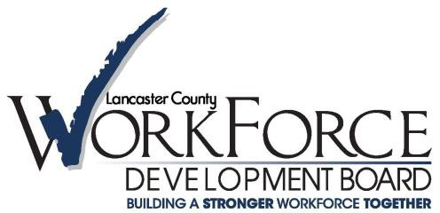

Local Management Committee (LMC) Agenda

# July 12, 2023 at 9:00 A.M.

[**Click here to join the meeting**](https://teams.microsoft.com/l/meetup-join/19%3ameeting_ZDk4NGE2ZTMtZGU3MS00MmY4LWEzYWYtNjg5NzVlZjM2Nzcz%40thread.v2/0?context=%7b%22Tid%22%3a%228bb0108f-860e-4670-ac62-00a80fc30e6c%22%2c%22Oid%22%3a%22fae7f5a9-5019-49c1-adf6-628639002a11%22%7d)

1. Welcome
   * Call to order
   * Roll call of members
   * Public Comment
2. Consent Agenda
   * Approval of April 12,2023 Meeting Minutes
3. Program Updates
4. LCWDB
5. CareerLink®
6. Around the room
7. Topic of the Day – Improving Partnerships
   * Challenges in partnering
   * Who else should be involved
   * Are we (or our clients) missing opportunities
8. Adjourn

# 2023 Meeting Schedule:

Time: 9:00am – 10:00am

Location: HYBRID 1046 Manheim Pike, Lancaster PA 17601 Board Room, 2nd Floor

* + Wednesday, October 11, 2023

# Links to check out:

PA CareerLink® Lancaster County: [www.jobs4lancaster.com](http://www.jobs4lancaster.com/)

Lancaster County Workforce Development Board: [www.lancastercountywib.com](http://www.lancastercountywib.com/)

Carissa Pinkard, Program Manager [Cpinkard@lancastercountywib.com](mailto:Cpinkard@lancastercountywib.com)

1046 Manheim Pike St. 2nd Floor Lancaster, PA 17601 717-735-0333 EXT: 229, 717-468-4544(C)